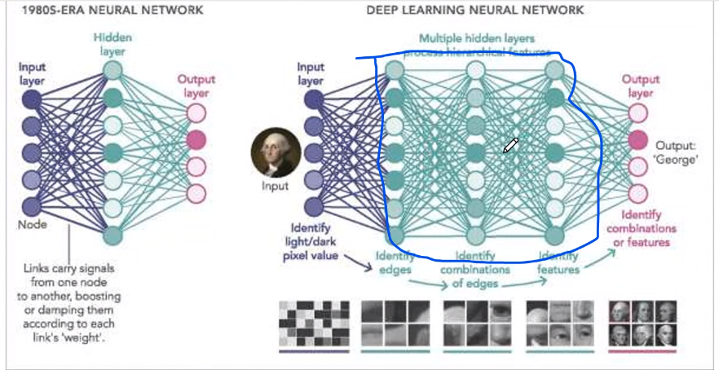

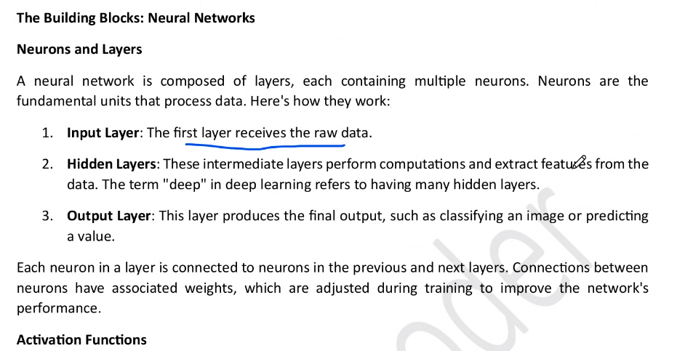

So many calculations are hidden in it, NLP : natural language processing is a part of it.

Google translator, ALEXA, voice techniques, chat bots are based on NLP, machine learning & deep learning.

Rule based, statistical based

HIDDEN LAYER has Activation functions top 3 are:

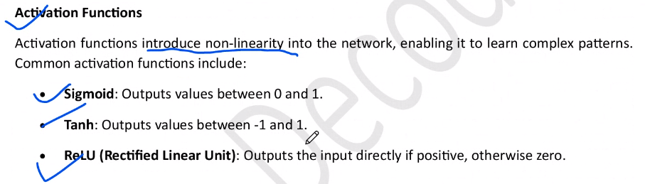

Here ReLU is a most common one we use.

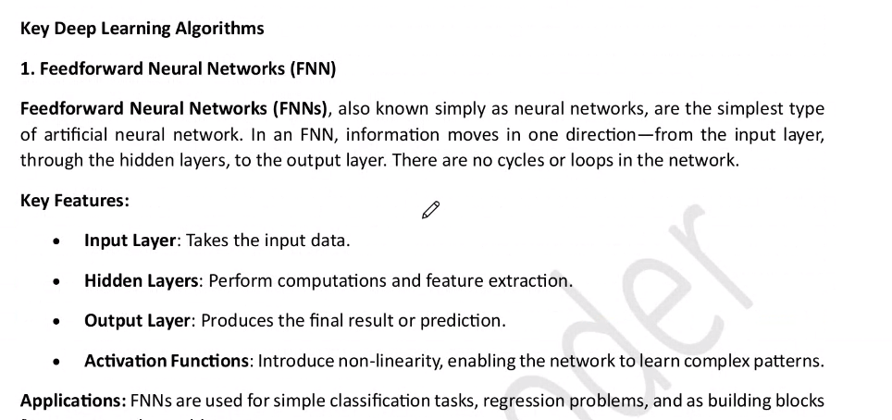

Soft max is an activation function

<https://www.keil.com/pack/doc/CMSIS_Dev/NN/html/group__CNNExample.html>



